Data Science Project

Executive Summary, Documentation, Project Report, Impact Evaluation

For the data science challenge, the author aims to build a model to predict expected passenger flights over the next year. They have used public datasets published by the UK Civil Aviation Authority. To develop an accurate and stable model for predicting flight traffic, they ensured that sufficient data was available. Data from the last four years (2021 to 2024) was downloaded, and current data for 2025 was sourced to test the model. The dataset includes information on public transport, training, and private flights.
The project will present the expected number of flights for the upcoming year, accounting for seasonal fluctuations in demand. Time series analysis will be employed to forecast future trends using the historical data collected. Additionally, a dashboard will be created to facilitate understanding of the dataset through exploratory data analysis (EDA) techniques, highlighting seasonal and regional variations. The model will incorporate Auto-Regressive Integrated Moving Average (ARIMA) for forecasting based on the past four years of data and will use Mean Absolute Percentage Error (MAPE) to evaluate performance and accuracy.
Findings from the model indicate that visitor numbers are projected to rise by 6.4% in 2025 compared to total flight numbers in 2024, reflecting the ongoing trend of year-on-year growth since the end of COVID-19 in 2021. Further improvements to the model could involve incorporating aviation fuel prices and weather metrics to assess their impact on travel numbers. Additional investigation could include competitor benchmarking to determine whether trends have shifted from budget airlines to more expensive package carriers, providing insight into where increases in travel are occurring.

Data Infrastructure & Tools

For this project, the primary tool used was Microsoft Excel. A dashboard was created in Excel, which served as a data processing platform, a data transformation tool, and an analytics solution. Within the organization, Excel is the most accessible tool, available to most employees with minimal cost and training requirements. Given that the dataset is relatively small, Excel meets the requirements for this project. Over the past decade, Excel has undergone significant transformation, making it a true powerhouse for modern data analytics (Mount, 2024).

Although Power BI could provide a more interactive dashboard with dynamic data visualization and the ability to handle larger datasets, limitations related to the target audience’s ability to use Power BI proved prohibitive. Similarly, Python offers various libraries for time series analysis, such as Pandas and Prophet, which would provide greater detail and scalability compared to Excel. However, for this project, Excel offers the right balance of data visualization for the exploratory data analysis (EDA) stage and time series analysis to forecast flight traffic for 2025.

Excel’s Power Query function was employed to import, clean, and transform the data. The data source from the UK Civil Aviation Authority website is stored monthly. Power Query was used as part of an Extract, Transform, Load (ETL) pipeline to ensure the data was uniformly cleaned, transformed, and loaded into the dashboard. Charts were then created to summarize the data visually, making it easier to interpret and understand.

Finally, the data was processed into a forecasting sheet to predict expected demand over the next 12 months, including upper (105% of forecast) and lower (95% of forecast) outcome ranges.

Data Engineering

Machine learning is an integral part of data science; it gives us tools and structure to help with analysis and prediction models. Machine learning can be broken down into three different areas.
- Supervised
- Unsupervised
- Reinforcement
For this project, supervised learning has been used, which concentrates on training models with labeled data to help, to help predict future values.
Finding a public data set, there will always be issues with the cleanliness and quality of the data, requiring a strong and reliable extract transform load (ETL) process(Palmer, 2025).
The first step in the process in the ETL pipeline is extract, where the data is pulled from the source, for this project it is extracted from the website from the UK Civil Aviation Authority. The data on the website is stored as monthly data sets. Since the covid pandemic struck in 2019, air travel was dramatically affected, with various countries preventing air travel, so I choose to extract data from 2021, as not to skew the forecast but putting in low data when we knew there were other issues affect air travel at the time.
The next stage in the ETL process is transformation. This is where we clean the data and transform it. To maintain continuity in the cleaning phase, a power query was created (figure 1). To avoid pulling in necessary data the date when the report was produced was removed, and the year and month were merged in the same column so they needed to split, so the data can organize in and sorted in a readable manor.
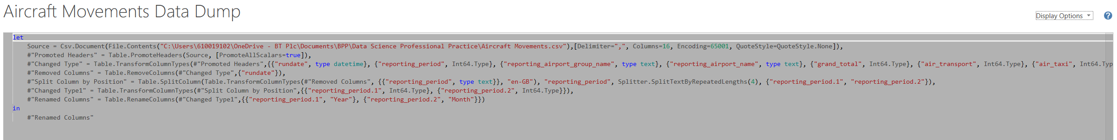
Figure1.

Whilst the data set from the Aviation Authority has been cleaned before publication, conditional formatting was set up, to ensure no duplications were present in the data set, which would potentially skew the results.
The final stage of the pipeline is loaded, and this was the data is loaded into the dashboard, ready for exploratory data analysis to see if we can see any pattern in the data. (Figure 2.)
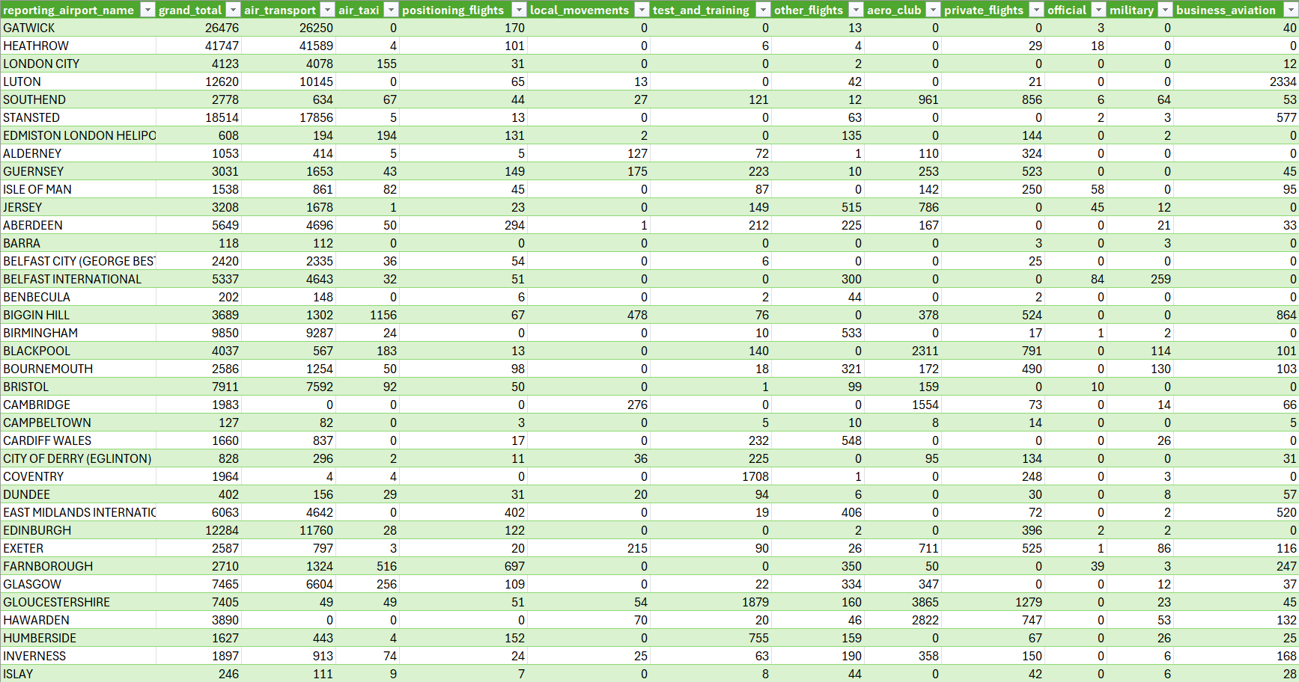
Figure 2.

Data Visualization & Dashboards
Once the data has been cleaned and loaded into a central dashboard, the author then created a pivot table so the data can be easily and efficiently manipulated using slicers to shape visualizations to make the data easier to understand (Jelen, 2024). Figure 3 shows the raw data, and we can see the seasonality of air traffic over the last 4 years.
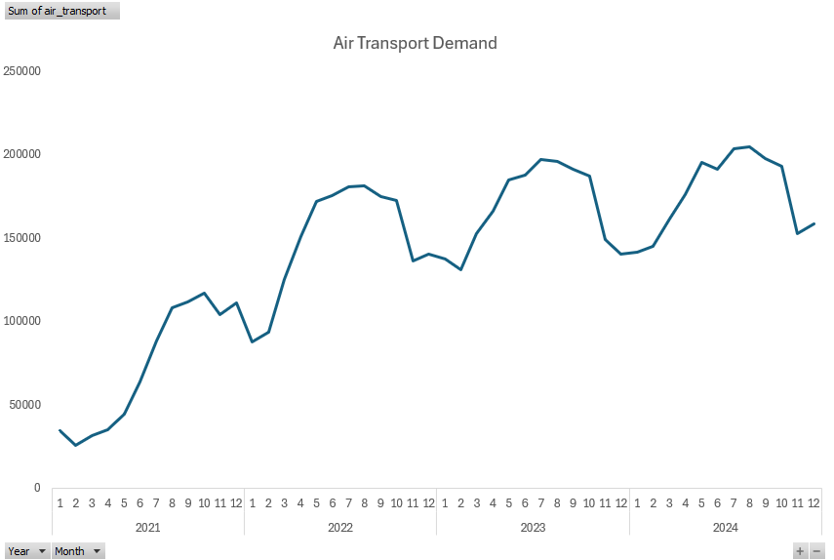
Figure 3.

The bar chart below, shown in figure 4, breaks down the seasonality more, you can easily see July to October are the most popular months to travel, with air travel dropping in November through to February before building again. This pattern is repeated throughout each year of data.

Figure 4.

The next step of the process was to identify the different areas the data set covers, the overall monthly total is made up of 11 different, from air transport, through to military and private flights. Figure 5 shows that 75% of the total is made up by air transport, so I have used this area to base my forecast on, to eliminate any discrepancies or irregularities in my data

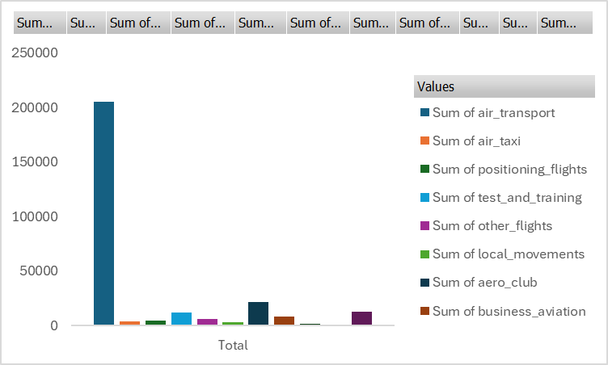
Figure 5.

The next step of the EDS process is to see which airports are the largest, and hold the most air traffic, in displayed in figure 6. We can confirm that the top 8 airports account for 50% of overall air traffic, we a remaining 50 airports accounting for the remaining 50% of overall air traffic, with the top three airports been in the capital London.

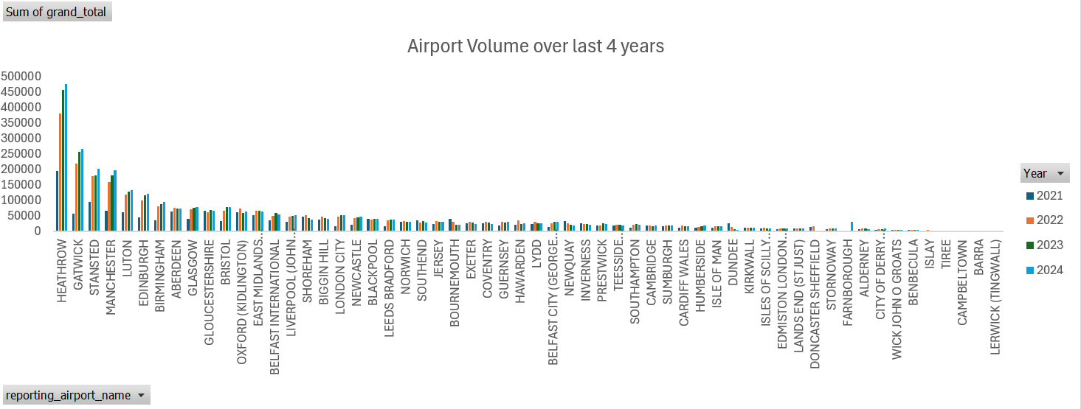
Figure 6.

Data Analytics

Now that the dataset is clean and we have confidence in the information presented and understand that it is free from errors and duplicate data. We can use data science to help predict the future and help understand the seasonality within the data set.
For this model we need a null hypothesis and an alternative hypothesis, to determine if the model is successful or if they affect is by chance(Downey, 2024).
The null hypothesis would be there is too much random noise in the previous four years of data to accurately predicate the future of find seasonal trends.
The alternative would be the model can accurately predict the with seasonal trends and provide an accurate model.
The next step to creating an accurate model is data smoothing, whilst there is seasonality in the data, there are short term fluctuations in the data, this could irregularly events or random issues which we can’t account for. By using data smoothing to improve the data set and make forecasting more accurate.
In this model the decision was made to use moving averages over fixed time scale, due to the seasonality of the data. To remove any irregularities and extreme data values, I used a 6-period moving average as seen in figure 7. The calculation of moving average drops a data point and incorporates a new data point instead. We can see from the trend lines that the linear demand is rising year on year, so we would expect

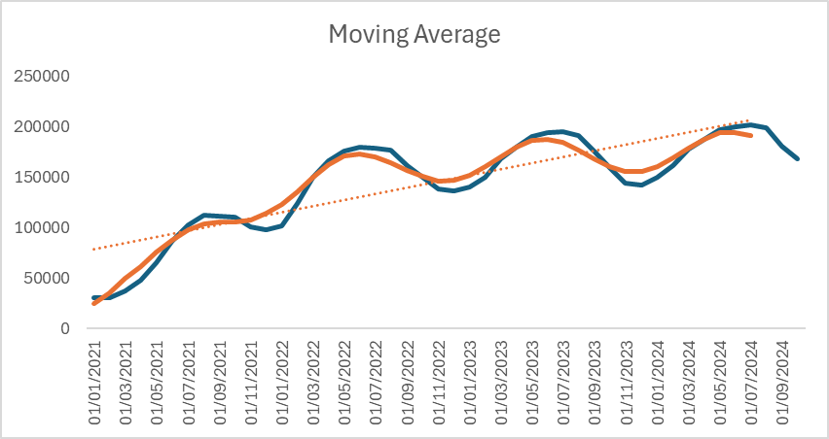
Figure 7.

Now that the data set is smoothed, for my model the next step is generate a forecast in excel. In excel the author used the data over the last 4 years as a train set, then used the excel formula “forecast.ets”, which uses exponential triple smoothing to predict the future value for 2025. The decision to use this formula is that it incorporates the seasonality of the data set, which in this model is based over 12 months of the year, which can be seen by the red line in figure 8.

Figure 8.

The forecast model gives a R2 value of 0.6303, which indicates a positive correlation.
The green line in graph 8 represents the test set data from 2025, and shows visually how accurate the model is, but we need to use a method to determine how accurate the model is.
We do this by using Mean Average Percentage Error (MAPE), which will provide a figure as to accurate the model is. In figure 9, we can see that the MAPR value is 4,5%, which means the average difference between the forecast value and the actual value is 4.5%.

Figure 9.

